**Template for New Properties**

Pictures of Properties: Please refer to Shared Drive as follows:

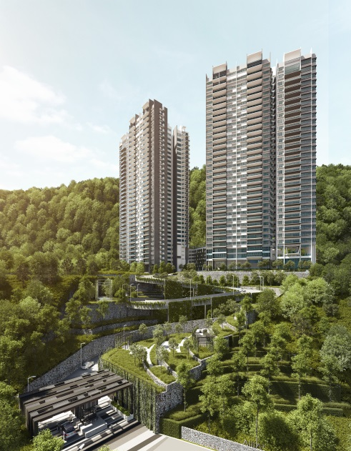

Title : ALILA2, Tanjung Bungah, Penang.

Title Brief : Condominium

Property Summary Details :

* Price : RM2,067,420 – RM5,830,000
* Average size : 1,905 – 5,789 sq.ft.
* Rooms : 3 to 5
* Bathrooms : 2 to 5
* Built Year : 2015

Additional Property Details :

Address : No. 50, Persiaran Lembah Permai,

11200 Tanjung Bungah, Pulau Pinang.

Completion Date : End of 2017

Tenure : Freehold

Total Number of Levels : Tower 1 (33 storeys) 132 units

Tower 2 (34 storeys) 138 units

Podium (7 storeys)

Total Number of Units : 270 units

Monthly Service Charge : RM0.30 per sq ft

Additional Description :

Designed for you; who appreciate nature’s nurturing and the serenity of sea breezes. ALILA 2 is the epitome of open spaces, breathtaking views and charming gardens; along with all the luxuries you would expect from a modern resort-inspired condominium.

**Property Highlights:**

* Located within the upscale Tanjung Bungah Locale
* Built on elevated land 223ft above sea level providing spectacular sea / hill views & auspicious Feng Shui
* Low density development with only 270 units on a 9.8-acre site.
* 5 star facilities with breathtaking landscaping worth over RM12 million.
* Designed to meet Green Building Index (GBI) Gold Certificate standards.
* Using a special glass that allows daylight into units but blocks out heat.
* A specially designed rainwater collection system that collects a stores rainwater for landscape watering.
* Using certified water efficient sanitary wares fittings that reduce water consumption by 50%.
* Generous green space with 47% of project land area is covered by trees and gardens
* 3-tier security
* Easy accessibility to Batu Ferringhi, Gurney Drive and a variety of attractions.
* Wide range of international schools & world-class medical centers within close proximity.

**Features and Amenities**:

24-hour Security

Aqua Gym

BBQ Area

Car Park Podium

Changing Rooms

Children Playground

Fitness Deck

Games Room 1 & 2

Guard House

Gymnasium

Half Basketball Court

Indoor Jacuzzi

Indoor Play Area

Lobby

Management Office

Massage Room

Meeting Room

Mini Theatre

Multimedia Room

Multipurpose Hall

Open Deck

Outdoor Cocoon Seat

Outdoor Jacuzzi

Outdoor Pavilion

Outdoor Play Area

Reading Area & Room Pool Lobby

Sky Gourmet Unit

Smart-Card Access

Steak Bath

Surau

Swimming Pool

Tennis Court

Terrace Garden & Feature Walkway

Utility Room

Video Intercom

Visitor Car Park

Wading Pool

Waiting Lounge

Water Massage Room

Wifi Lounge

Yoga Deck

**Layout Type and Sizes:**

|  |  |  |
| --- | --- | --- |
| Type | Build-up area |  |
| Type A | 3,235 | Typical Unit |
| Type B/B1 | 2,397 | Typical Unit |
| Type C | 1,947 | Typical Unit |
| Type D | 1,905 | Typical Unit |
| Type E | 3,900 | Penthouse |
| Type F | 4,728 | Penthouse |
| Type G | 4,807 | Penthouse |
| Type H | 5,789 | Duplex |

**Fully Furnished Package available.**

Property Map (will be using google map, postal code): GPS Coordinates: 5.453470, 100.290688

Link to Landing Page (URL): <http://www.alila.com.my>